Hello my dear students, the following guide is designed to help you consolidate the content received from unit 1 to 8. By reviewing these contents, you will strengthen your skills.
Please answer each of the following activities taking into account the characteristics of a PORTFOLIO. Remember that a portfolio is an organized collection of evidence of a progress, achievements, and reflections over time. It is not just a file of assignments but a tool for their assessment.
Through structure activities you will practice writing clear sentences, describing people and places and applying conventions of text organization. The main goal is to strengthen your ability to communicate ideas in English with accuracy and creativity.
Unit 1. Parkview Street
Main communicative functions:
- Ask and say where people are from
- Ask and say how old people are
- Ask and say where people live
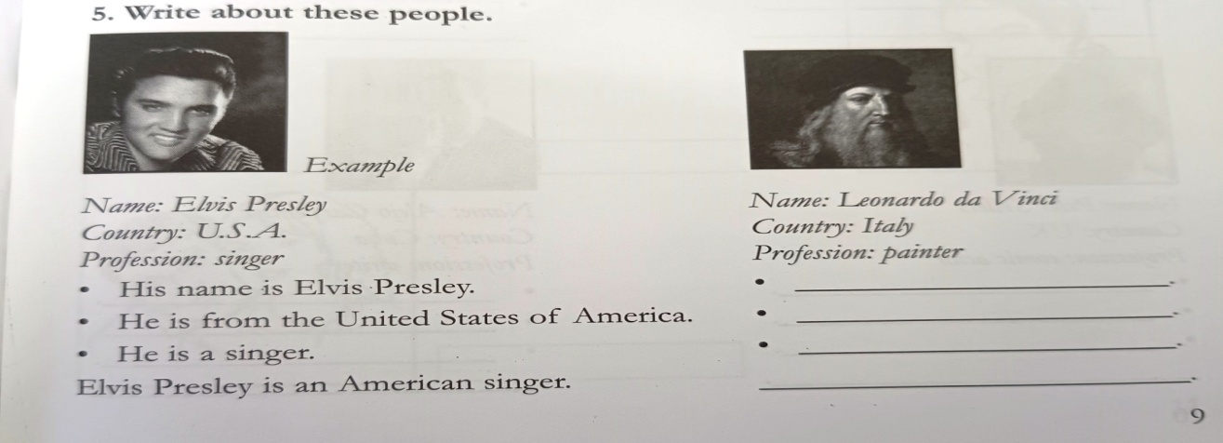
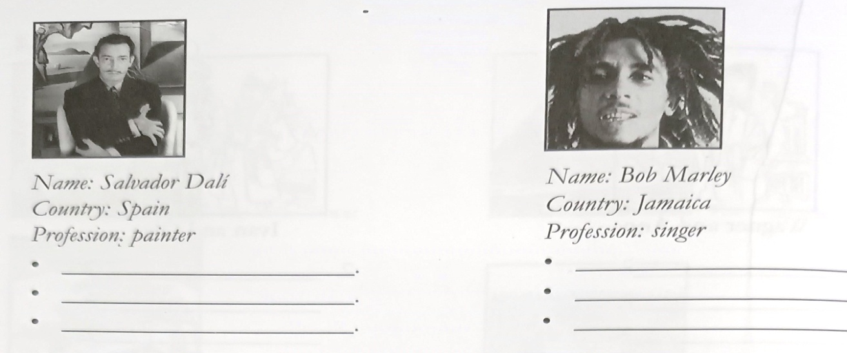
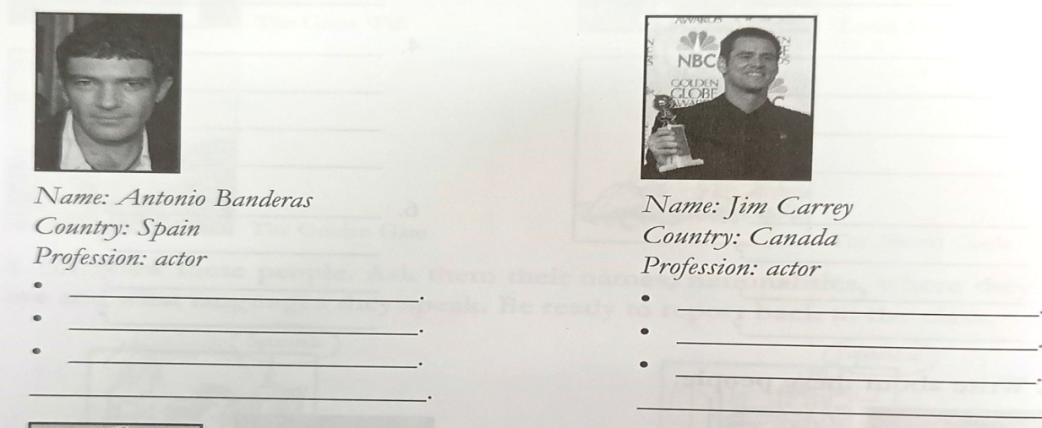
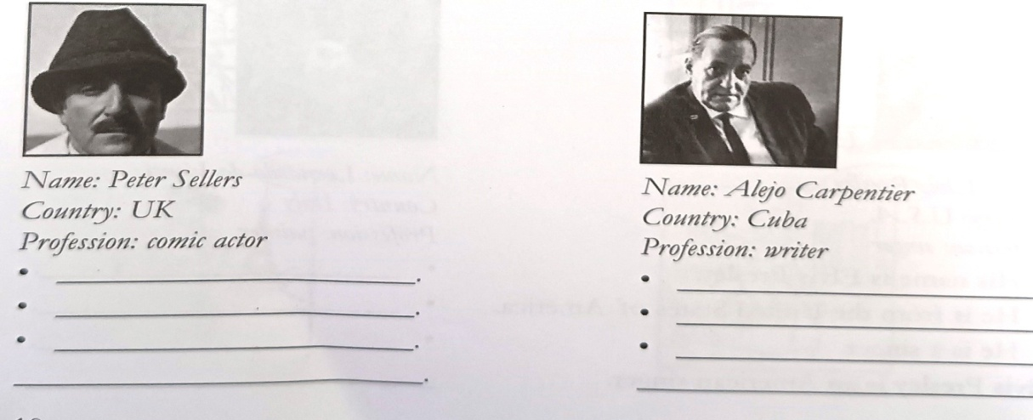
Note: To improve your writing skills through this activity, you will write a paragraph about each of the famous personalities; if necessary, look up more information about them on the internet.

Unit 2. A visit to Margaret’s apartment
Main communicative functions:
- Describe your house
- Ask and say where places are in town
- Describe people physically
2. These are Jane’s and Meg’s living rooms. Describe what there is in these rooms.
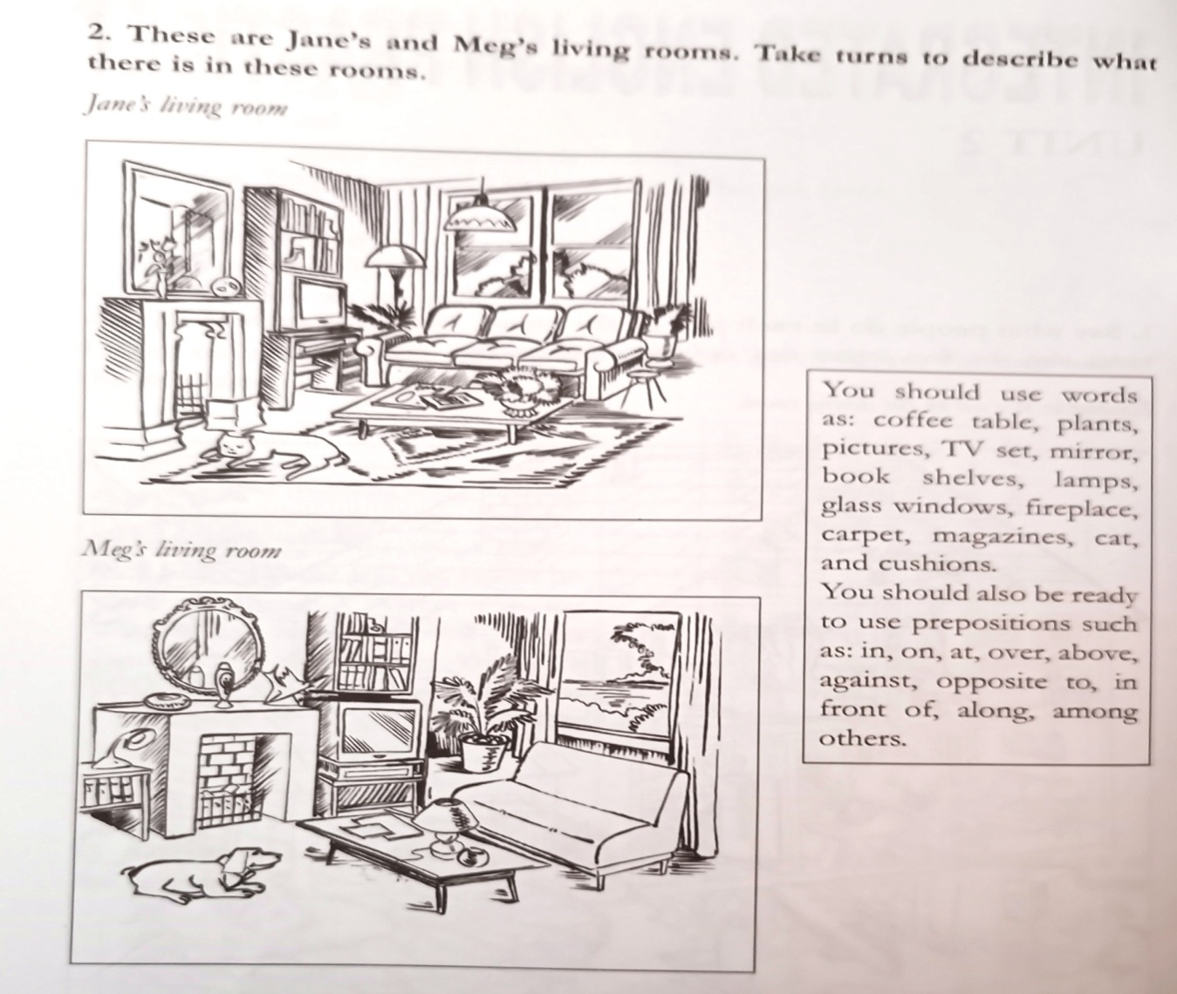
5. This is Bill’s apartment building. He is very happy with it because it is located in a very convenient place. Use the picture to describe bill’s neighborhood.
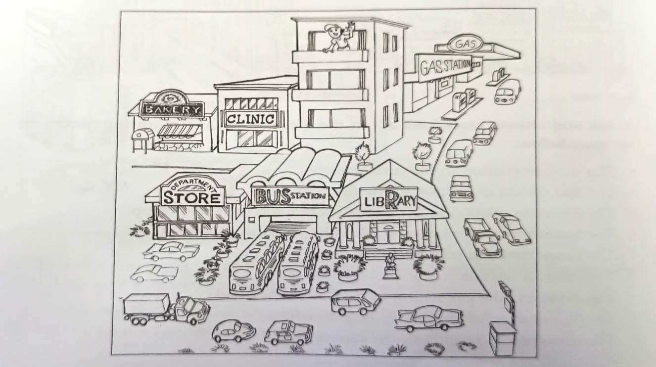

Unit 3. The best way to go Greenwood
Main communicative functions
- Ask and give information about people’s family
- Make comparisons
- Make suggestions
3. Use the following list of adjectives to tell your partner what you think about each of the following means of transportation.
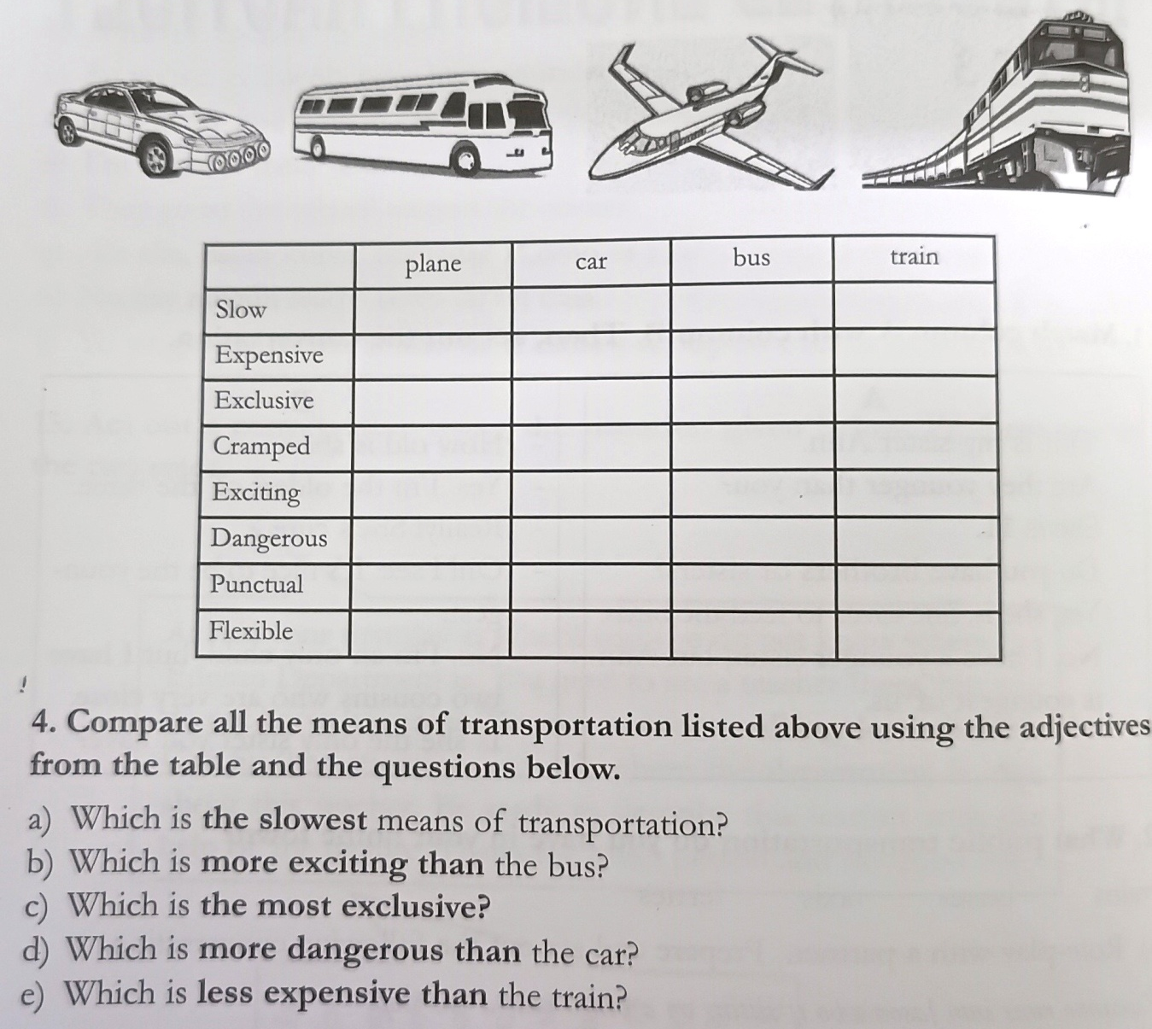

Unit 4. People who love their jobs
Main communicative functions
- Ask and give information about someone’s job
- Describe jobs
- Say how much you like or dislike your job
10. Look at the picture below and write in a paragraph what these people are doing.
- Also practice your translation skills with exercise 11.
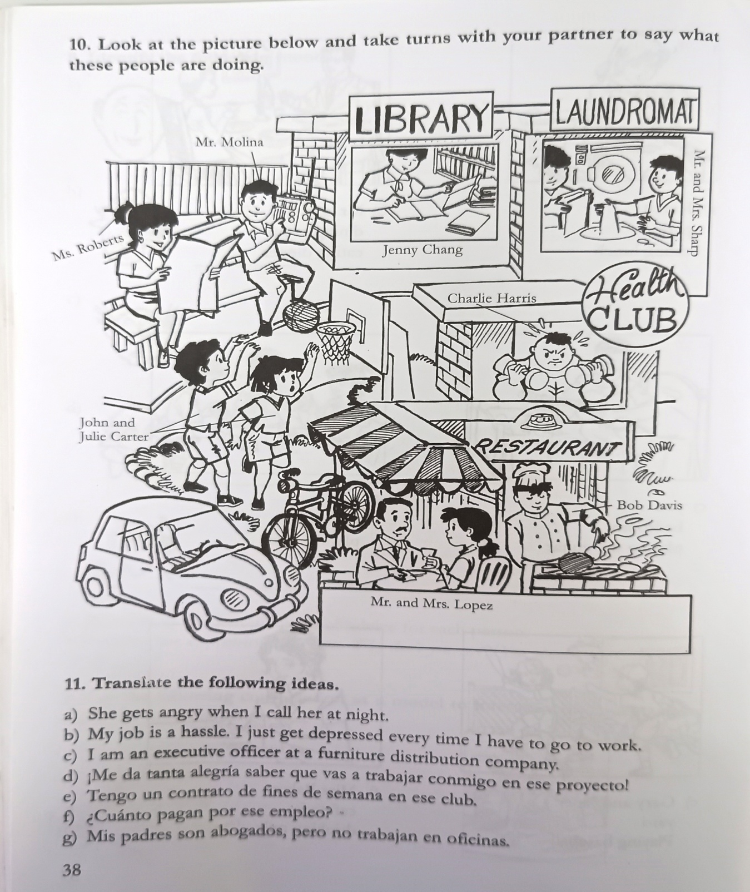

Unit 5. A surprise call to Melanie (Review)
Main communicative functions
- Ask and say how people are
- Talk about what people do
- Describe people physically
- Describe people’s personality
- Compare people physically and in terms of their personal traits
8. What do you think about these people? Select one of them and describe him/her, begin like this: This person is…
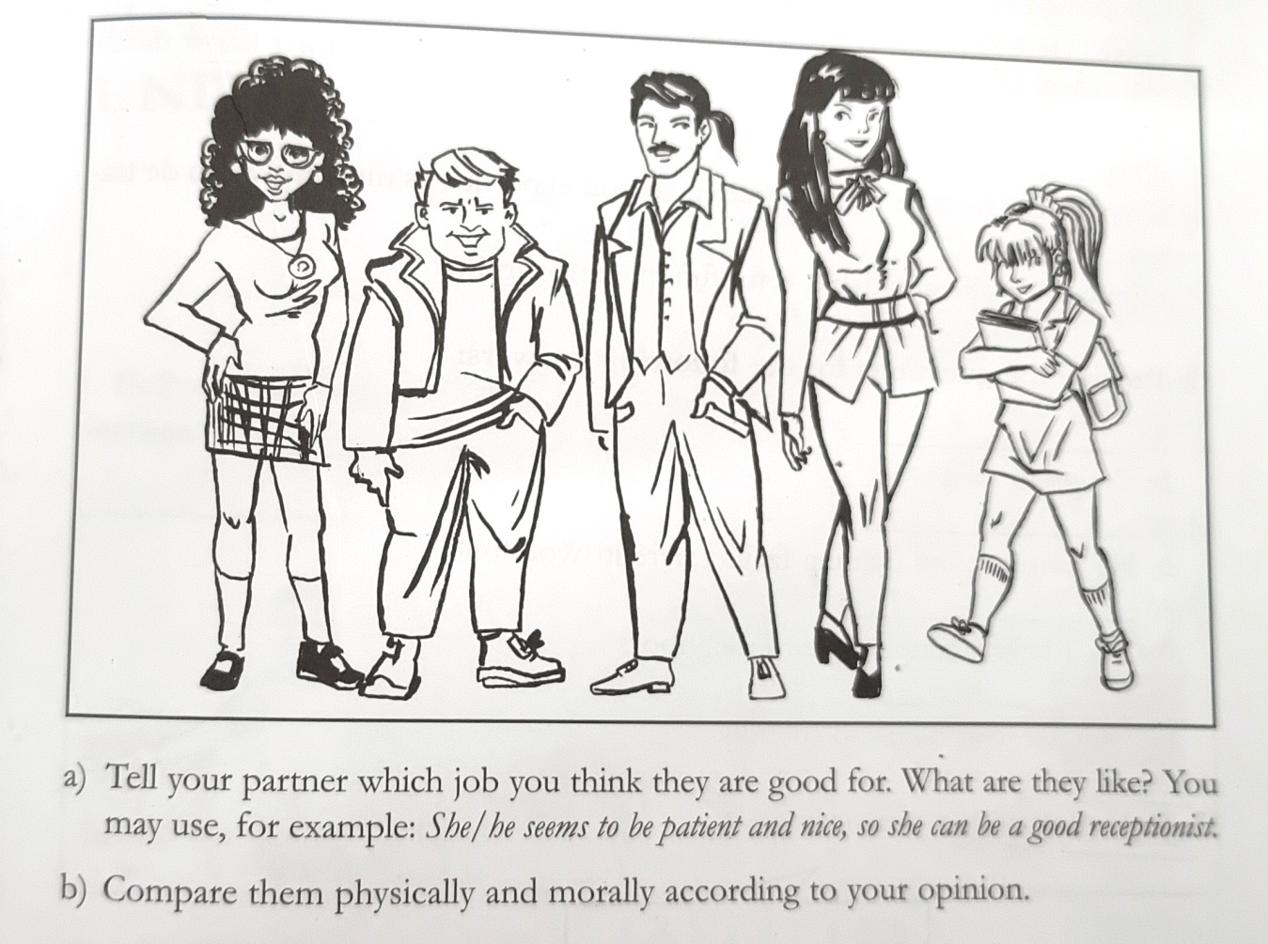
9. Select one member of your family and describe him/her physically and morally.
Unit 6. Awful weather
Main communicative functions
- Ask and say what is happening
- Report what someone is doing
- Ask about and describe the weather

4. Look at these pictures. Answer the questions below and provide the correct idea fro the negative cases.
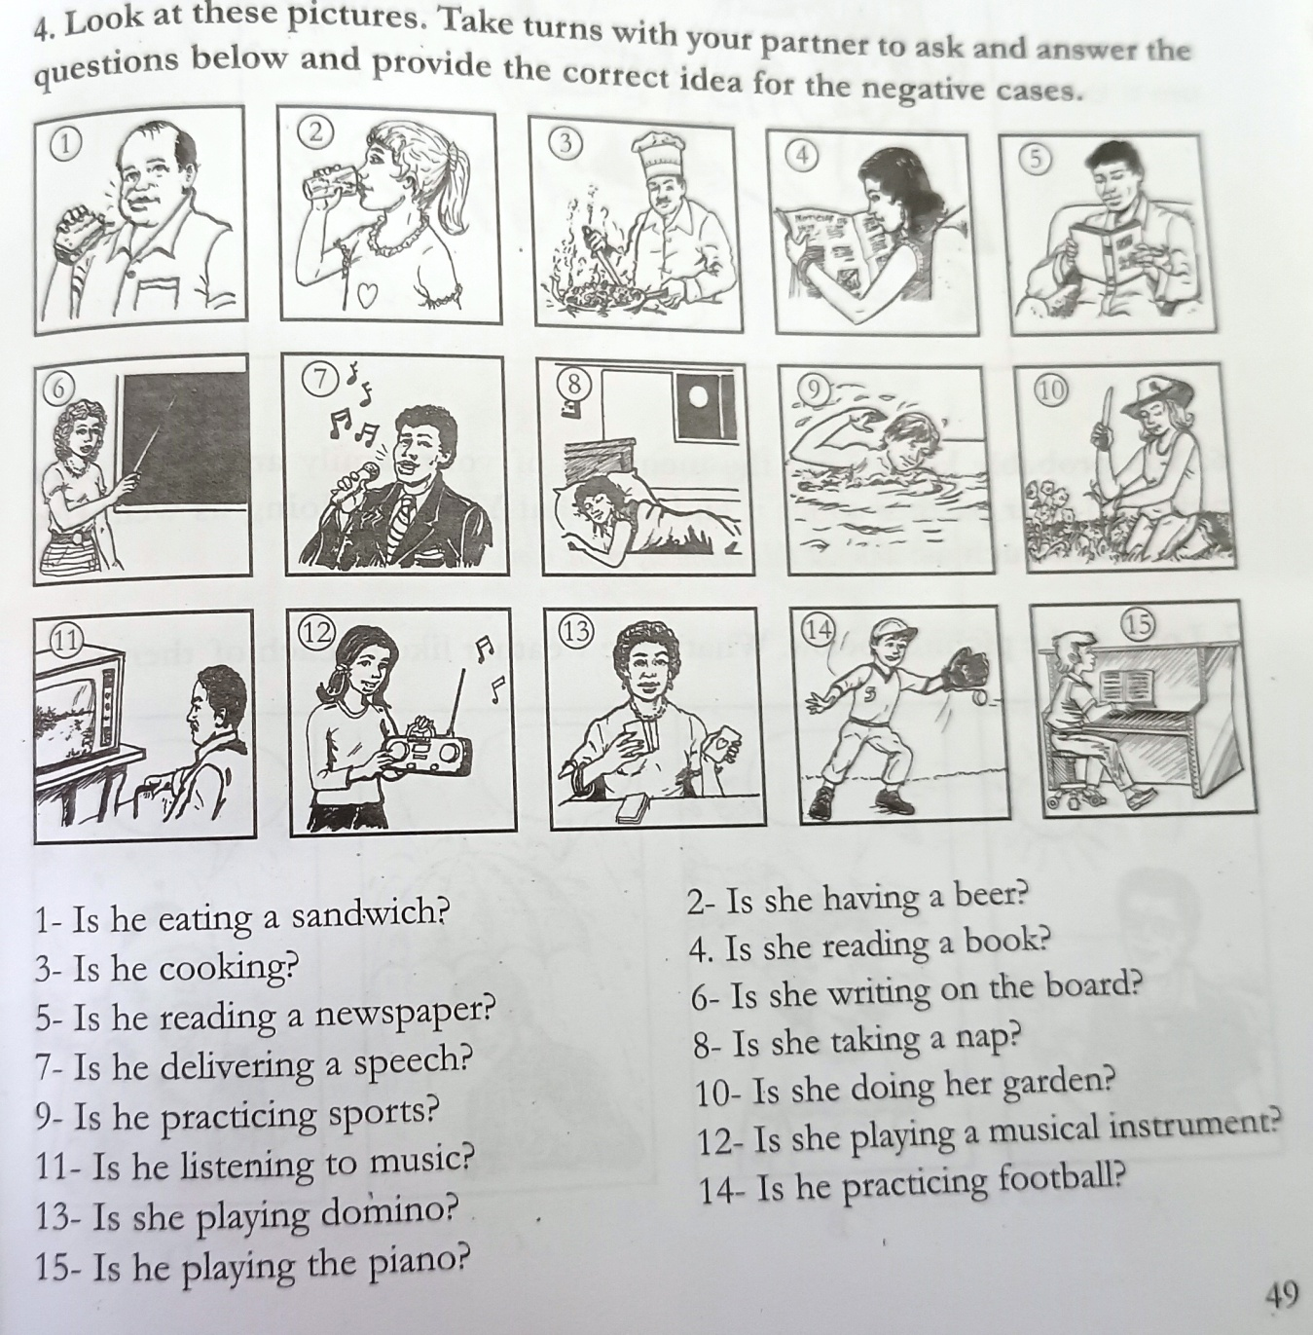
7. Look at the pictures below. What is the weather like in each of them?
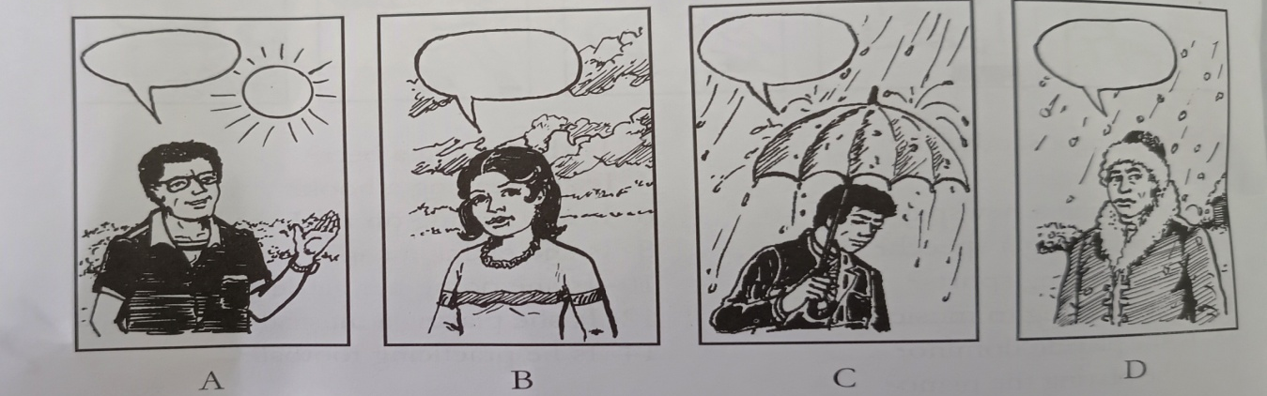
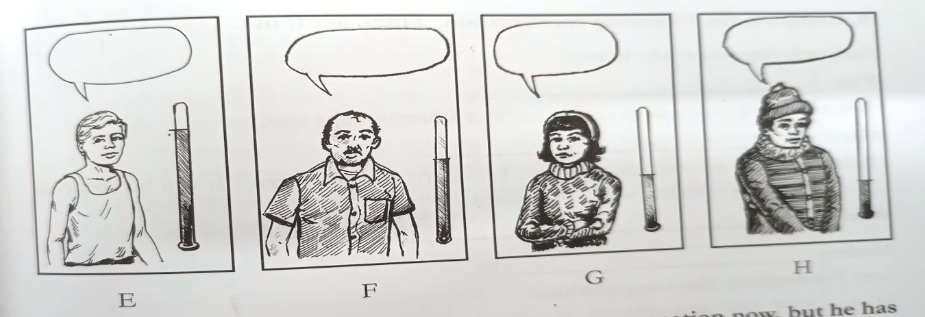
11. Translate the following sentences.
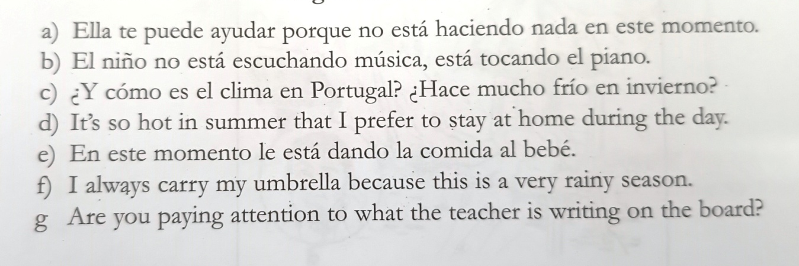
Unit 7. Klaus’s daily routines
Main communicative functions
- Describe routines, habits, pastimes and hobbies
- Ask and say how often something is done
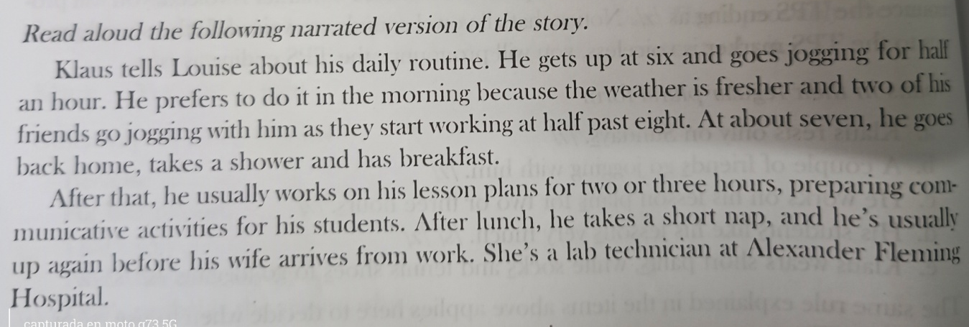
5. Compare “Klaus’s daily routines” with your own and with that of the student sitting next to you in relation to the following items:
-Write sentences about you and your classmate using the information in the chart.
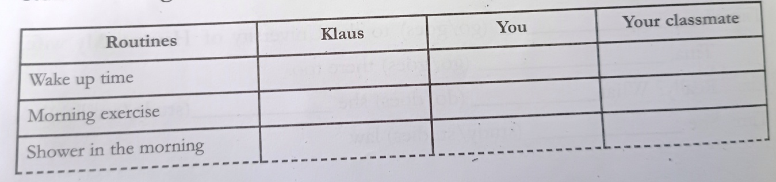
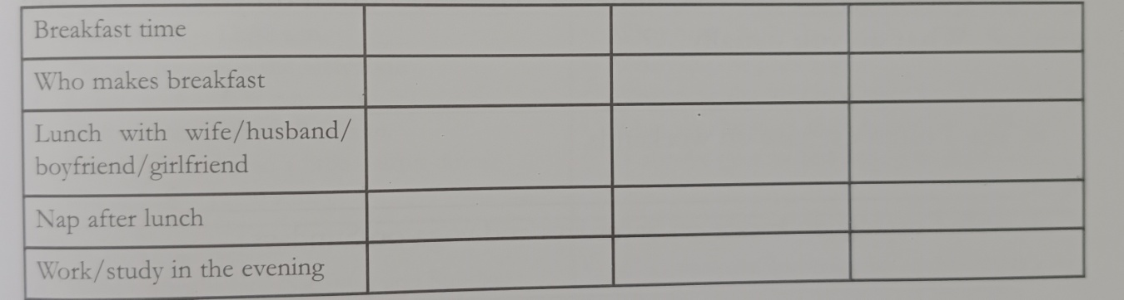

Unit 8. Family plans
Main communicative functions
- Suggest something
- Ask and talk about likes and dislikes
- State a preference
