Unit 9 Directions in Newtown
Main Communicative Functions
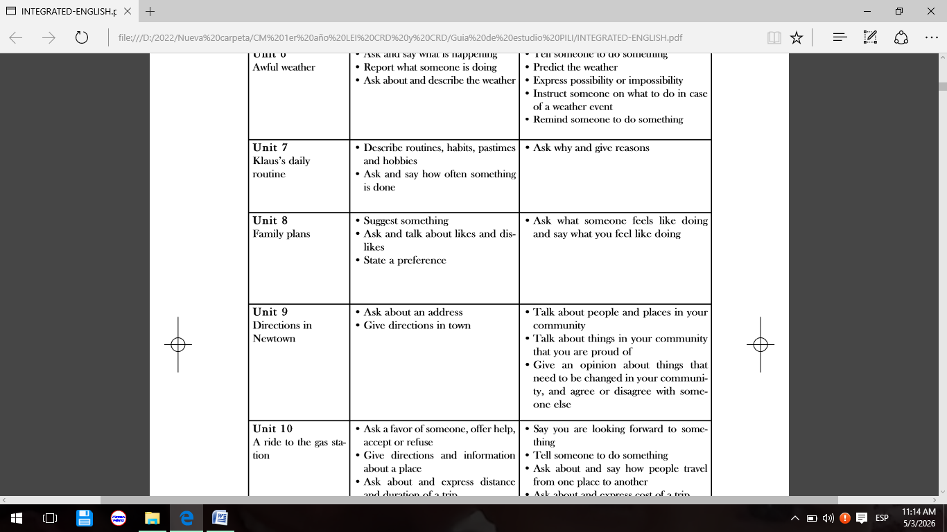
Secondary Communicative functions
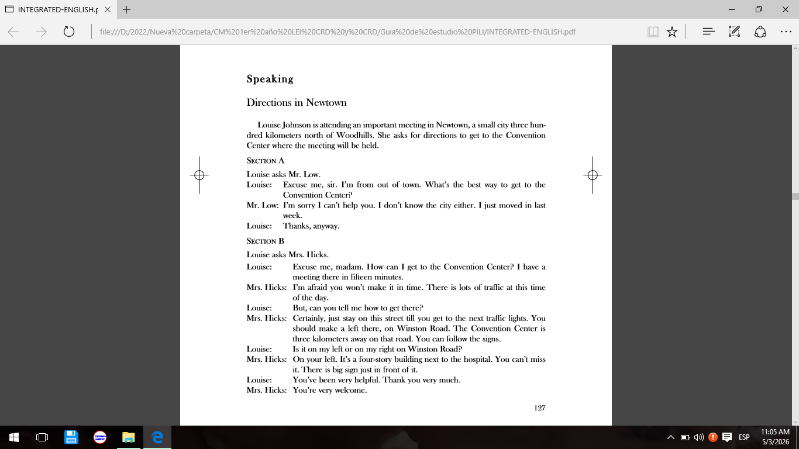
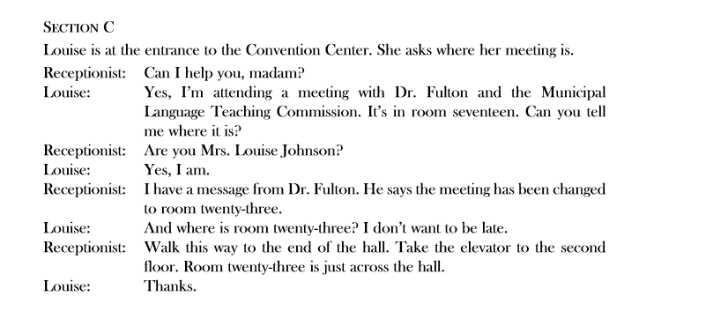
- Ways of asking about an address
How do you say it?
- What is the best way to get to the convention center?
- How can I get to the convention center? Can you tell me where it is?
- Do you live in town?
- Do you live in outskirts of the city?
- Do you live out of town?
- Do you live near the park?
- Do you live across from the Havana Libre Hotel?
- Where exactly do you live?
- What is your address?
- Where is the city Hall in your town?

- Ways of giving directions in town
Some examples
- I am sorry I cannot help you. I do not know the city either.
- Just stay on this street till you get to the next traffic lights. You should make a left on Winston Road. The convention center is there kilometers away on that road. You can follow the signs.
- Walk straight ahead for three blocks.

Read the dialogue as many times as you need; look for difficult words and phrases; if necessary consult the supplementary materials that were uploaded for working with the unit, and answer the exercises 1, 2, 4 and 5 page 67, 68, 69, workbook.

