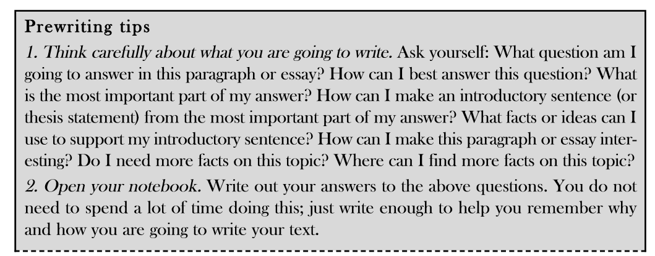
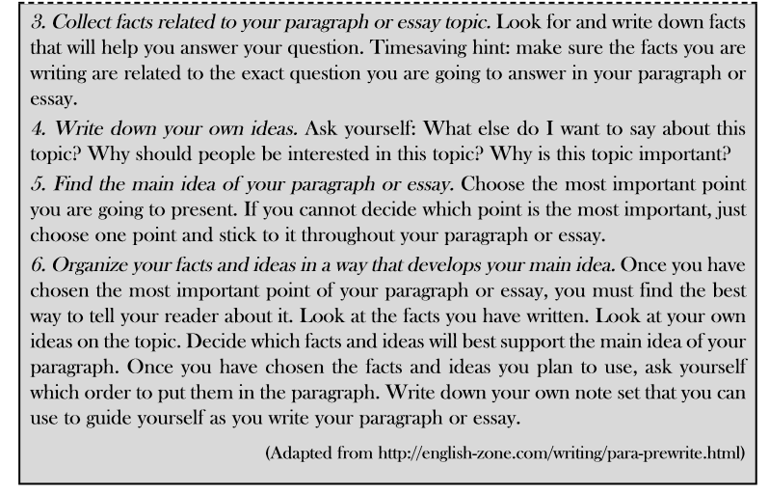
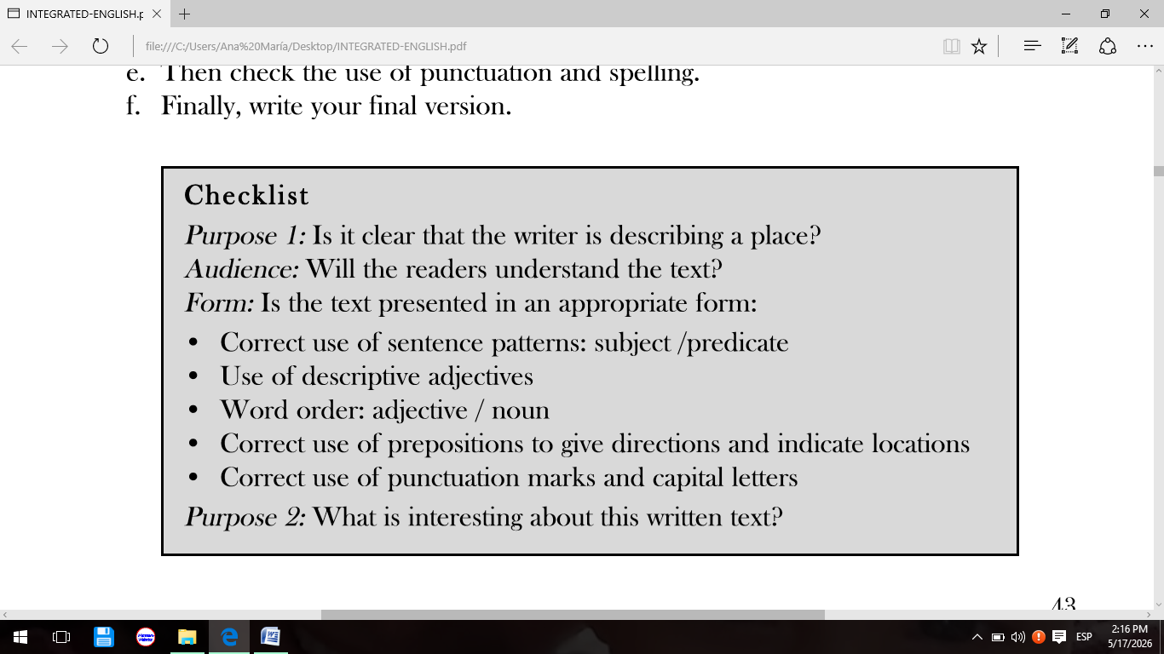
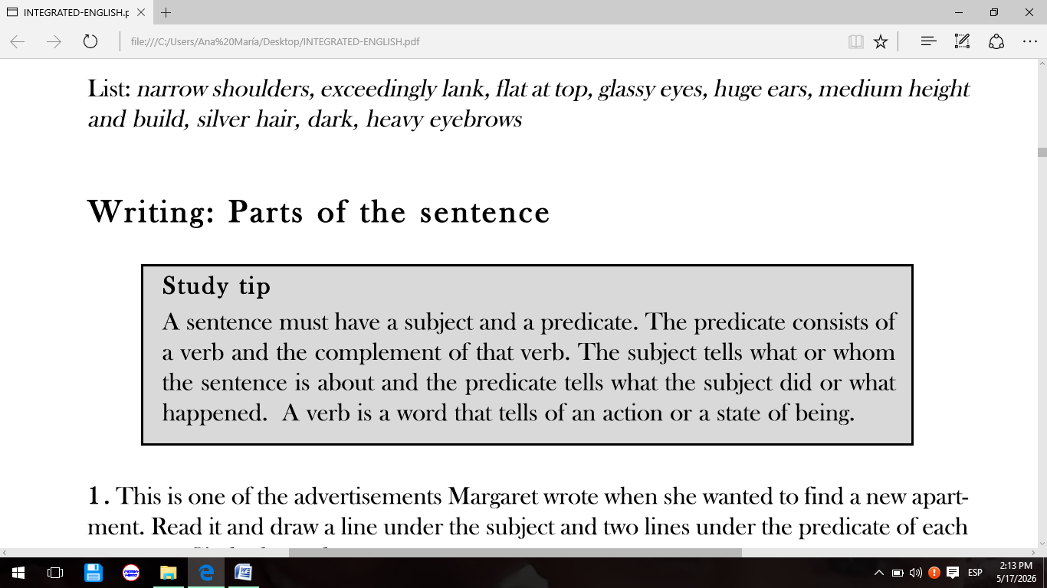

Project work
Widening your knowledge about some of the most important historical places in your town, city or province is part of the necessary culture any foreign language teacher should have. It will be a good start if you select, describe, say where is located (use prepositions and adverbs of place), and create an information sheet for visitors/tourists.
- Use the “Pre writing tips” at the top of this document to help you in your work.
- Make sure it is clearly understood what you are writing by consulting the “Checklist” at the top of this document.

