Read dialogue 10 “A ride to the gas station”, look for difficult words and phrases and be ready to answer the activities that follow.
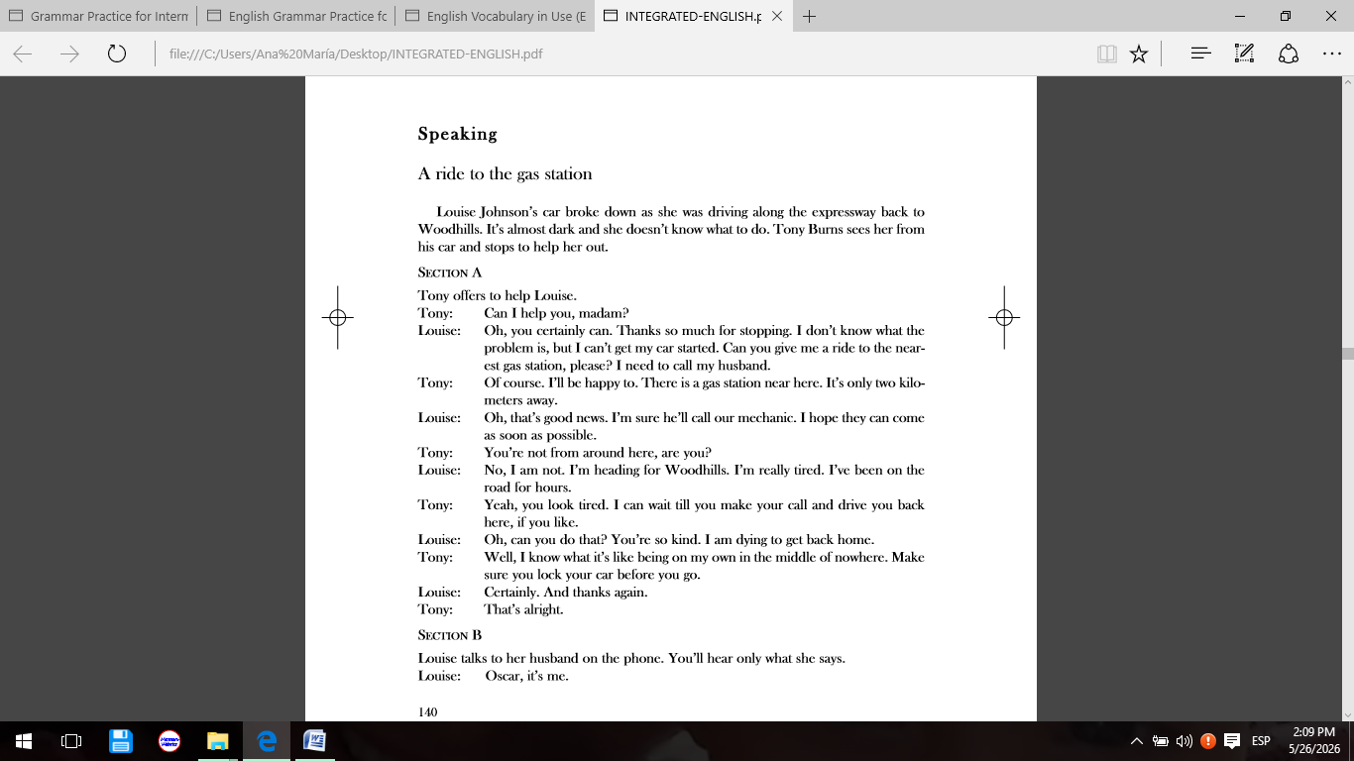
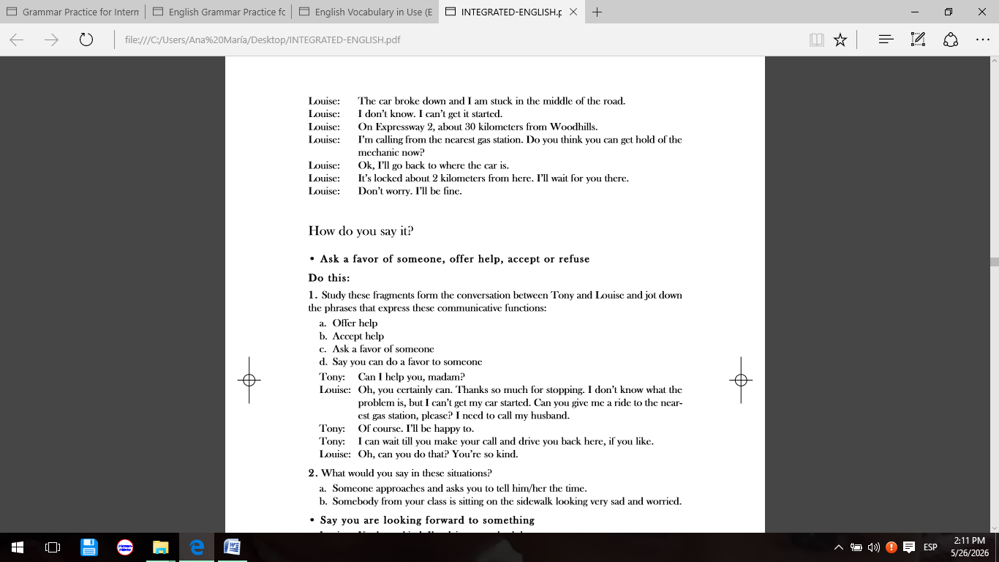

-Practice with communicative functions
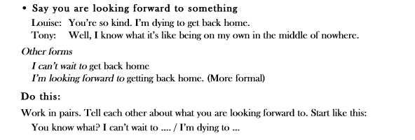
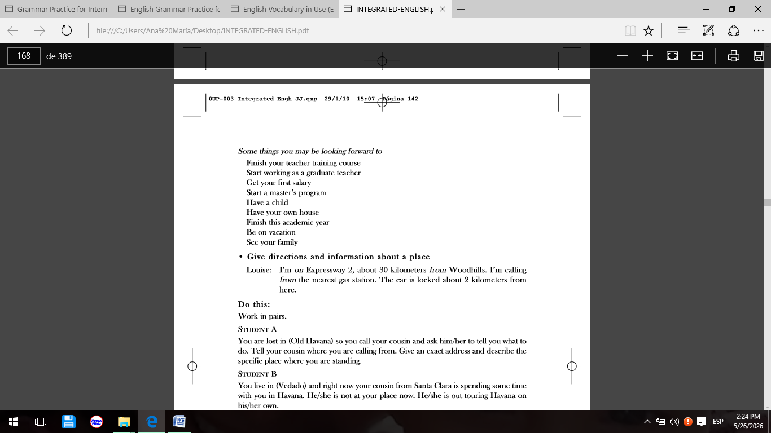

-Once you have finished with this part, you are ready to answer exercises 1, 2 pages 73 and 74 Workbook.
-Consult the bibliography uploaded to the platform unit 10, particularly the themes related to the use of modals in English, and be ready to answer exercises 3, 5, 8 pages 74, 75 and 77 workbook.
-Last but not least, to conclude this task you will answer exercise 2 on page 73 from the workbook.

