Time for practicing

Read carefully and analyse the information presented in each of the pictures below; take notes if necessary.

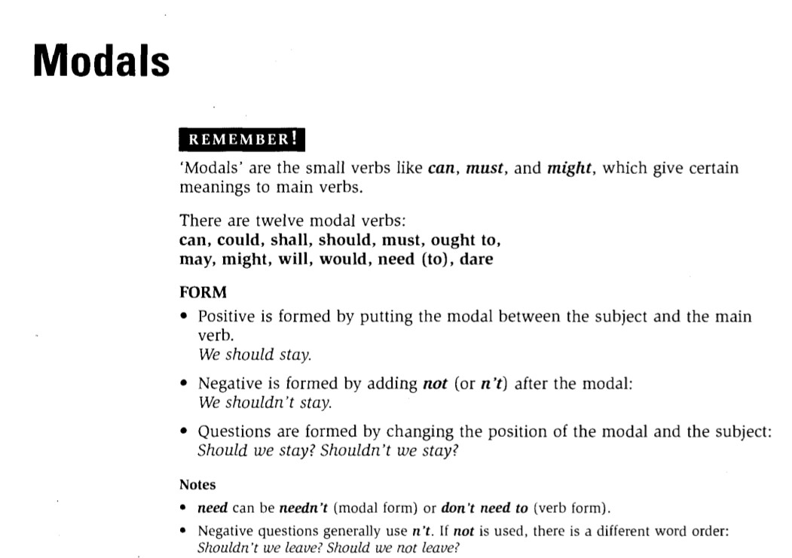

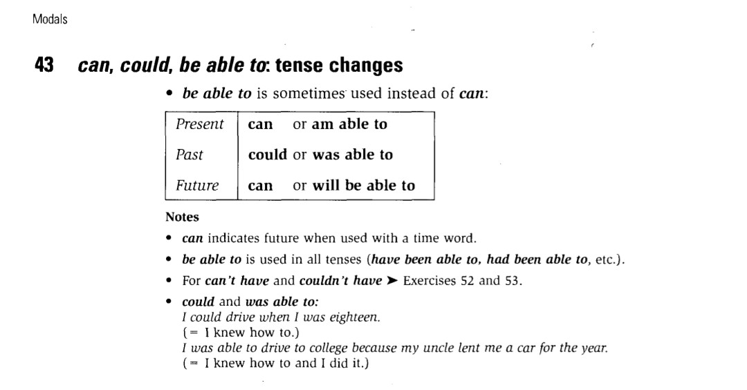

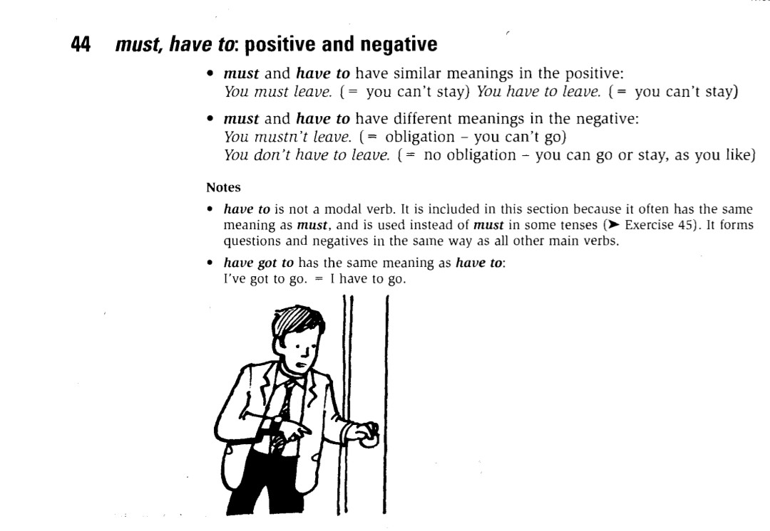

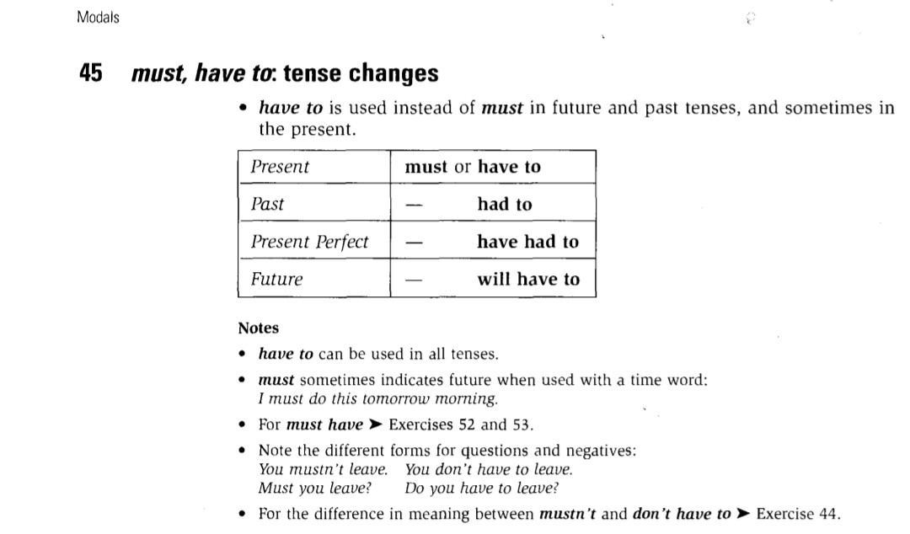

You are now ready to work on the Speaking section of your textbook ( page 182), specifically the reading text “At the sports center” and be ready to answer the activities that follow.

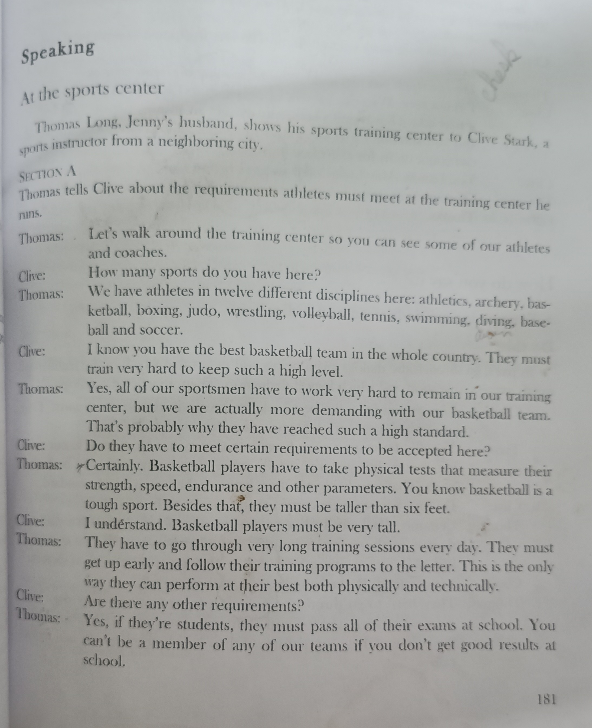

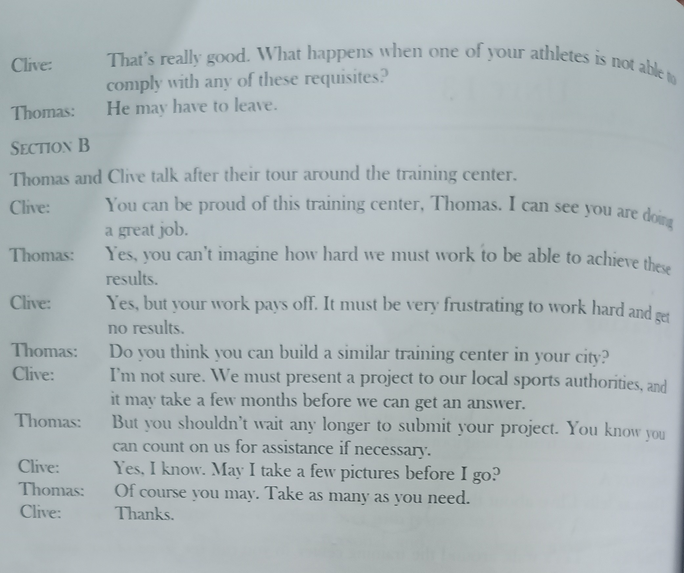

- Go through the reading and underline all expressions indicating obligation or possibility.
- Look for vocabulary related to sports disciplines and try to group them according to these categories:
- Indoor sports
- Outdoor sports
- Sports played with a ball
- Sports that need a racket to be played
- Water sports.
- Read the text again and copy some expressions in which the speaker is:

- Expressing logical deduction and obligation
- Asking for and giving information about a place
- Expressing possibility
- Asking for and giving an opinion

